
A 10
SET NO : 1

Sreenidhi Institute of Science & Technology
(An Autonomous Institution)
Code No: 101EE41/111EE41
E
B. TECH. I – Year II – Semester Examinations, June/July, 2012 (Regular/Suppli)
BASIC ELECTRICAL ENGINEERING (Common to ME, CSE, IT & BT)

Time: 3 Hours Max. Marks : 70

Note : No additional answer sheets will be provided.

Part-A (Objective Type)
Max.Marks:20

Answer all QUESTIONS.

1) Explain about Kirchoff's Laws.
2) Explain Faradays Laws of Electromagnetic induction.
3) Define cycle and frequency.
4) A sine wave is represented ·by the equation e=144sin(314t- Π/3) calculate the frequency.
5) Write the relation between applied voltage and back emf for a dc motor.
6) Write the emf equation of a transformer.
7) If full load cu loss of a transformer is 1600watts, its cu loss at half -full load would be_______________.
8) Define slip of 3-phase induction motor.
9) Write a short note on deflecting torque.
10) A 6-Pole induction motor is fed by 3-Φ 50Hz supply and running with a full load slip of 3%, find the frequency of rotor emf.
Part – B
Max. Marks: 50
ANSWER ANY FIVE QUESTIONS. EACH QUESTION CARRIES 10 MARKS.

1. a) In the circuit of below figure find the equivalent resistance terminal A and C ? [ 5 ]
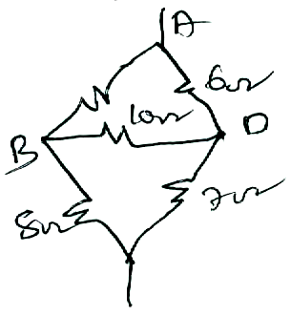
C
4 Ω

b) State and explain superposition theorem. [ 5 ]

2. a) State and explain Thevenin's Theorem. [ 5 ]

b) Find the Thevenin equivalent circuit of the network shown in below then find the current through R_{L} for value of 9 Ω. [ 5 ]
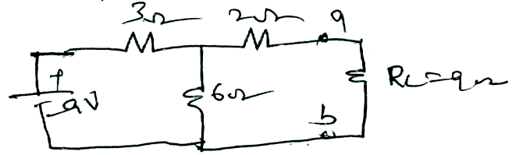
3. a) Define the following [ 5 ]
i) Alternating quantity ii) RMS Value iii) Average Value

b) Find the average and effective values for the function e(t)=E_{m}sin ωt [ 5 ]

4. a) Derive an expression for emf equation of DC Generator. [ 5 ]

b) A 4-Pole lap wound armature has 840 conductors and flux/pole of 0.018wb.
Calculate the emf generated, when the machine is running at 500rpm. [ 5 ]

5. a) Derive emf equation of 1- Φ Transformer. [ 4 ]

b) Explain the losses in a transformer with the help of O/C and S/C tests. [ 6 ]

6. a) Explain the Principle of Operation of 3- Φ Induction motor. [ 5 ]

b) a 3-Φ 6-Pole induction motor is supplied from a 50Hz, 400v supply calculate
[ 5 ]
i) The synchronous speed and
ii) The speed of the rotor when slip is 4%. [ 5 ]

7. a) Derive relation between line voltage and phase voltage in a three phase start circuit with a neat phasor diagram. [ 5 ]

b) A balanced three phase load consists of three coils each of resistance 4 Ω and inductive reactance of 6 Ω. Determine the line current and power absorbed when the coils are [ 5 ]
i) star - connected ii) delta - connected across
420V, 3-phase supply

8. a) Explain shunts and multipliers for the extension of range of instruments. [ 5 ]

b) Explain the significance of controlling torque and damping torque relevant to the
operation of indicating instruments. [ 5 ]

-- 00 -- 00 --

